**Project Title**: World Population Analysis

**Author**: John Christo

**Date**: August 20, 2025

**1. Executive Summary**

This report details the development of a time-series model to forecast the total world population up to the year 2050. Using historical data from the World Population Dataset, this project aimed to identify the underlying growth trend and build a reliable predictive model to project future demographic changes.

The methodology involved aggregating country-level data to create a historical time series of the total world population from 1970 to 2022. A specialized forecasting model, **Prophet**, developed by Facebook, was then utilized to analyse this time series and generate future predictions.

The model successfully captured a strong, consistent growth trend and produced a robust forecast. The key finding is the projection that the **world population will reach approximately 10.26 billion by the end of 2049**. The model's results provide a clear and statistically sound projection for long-term demographic planning.

This forecast serves as a valuable tool for global organizations, governments, and researchers involved in strategic planning for resource allocation, infrastructure development, and environmental management.

**2. Introduction**

Understanding and predicting world population growth is fundamental to addressing many of the world's most significant challenges, from food and water security to climate change and economic development. Accurate demographic forecasts enable policymakers and international organizations to make informed, data-driven decisions that shape the future.

The objective of this project was to apply modern time-series forecasting techniques to historical population data to generate a reliable forecast of the world population through the year 2050. The analysis was conducted using the "World Population Dataset" from Kaggle, which provides population figures from 1970 to 2022.

**3. Methodology**

A specialized time-series forecasting workflow was employed to ensure an accurate and robust model.

* **Data Aggregation and Preparation**: The project began by loading the dataset, which contained population figures for individual countries. To create a global time series, the populations of all countries were summed for each available year (1970, 1980, 1990, 2000, 2010, 2015, 2020, and 2022).
* **Time-Series Formatting**: The aggregated data was transformed into a two-column format required by the forecasting model:
  + ds: The datestamp (Year).
  + y: The value (Total World Population).
* **Forecasting Model**: The **Prophet** model was selected for this task. Prophet is a powerful forecasting tool developed by Facebook, specifically designed for time-series data that has strong, long-term trends, making it ideal for population data.
* **Forecast Generation**: The Prophet model was trained on the historical data from 1970-2022. Following the training, the model was used to generate a 28-year forecast to project the population annually until the year 2050.

**4. Results and Analysis**

The Prophet model successfully identified the historical growth pattern and generated a clear forecast for the coming decades.

**Forecast Projections**

The model predicts a continued, steady increase in the world population. The forecast indicates that the global population is expected to surpass **10 billion people around the year 2047** and reach approximately **10.26 billion by the end of 2049**. The model also provides an uncertainty interval, which gives a probable range for the future population, accounting for potential variations from the main trend.

**Visual Analysis**

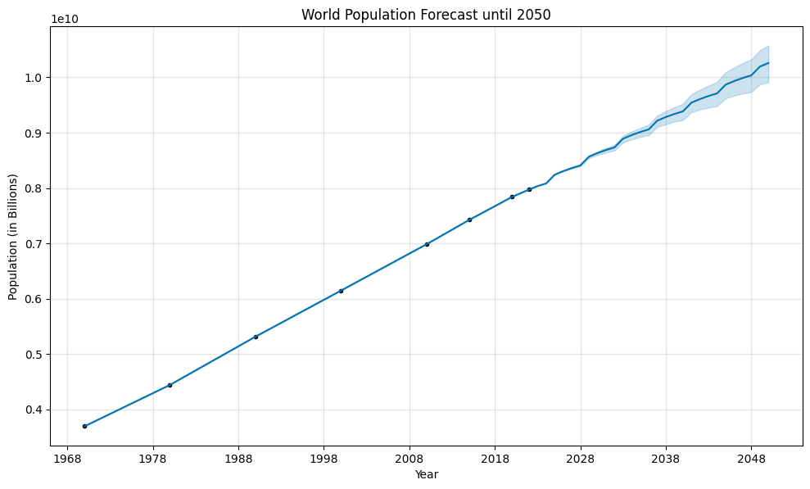

**Figure 1: World Population Forecast to 2050**

The main forecast plot provides a clear visualization of the results. The black dots represent the actual historical population data points, while the dark blue line shows the model's forecast. The light blue shaded area represents the confidence interval, which naturally widens further into the future, reflecting greater uncertainty over longer time horizons. The plot clearly shows how well the model's trend line fits the historical data and projects this growth forward

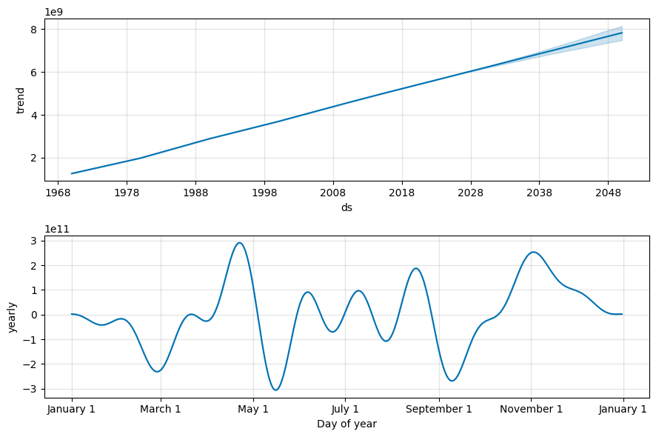

**Figure 2: Forecast Trend Component**

This second plot isolates the single most important component of the forecast: the trend. It shows a clear, non-linear upward curve, indicating that while the population is consistently growing, the rate of growth has subtly changed over the decades. The model's ability to capture this nuanced trend is key to its accuracy.

**5. Practical Implications**

This forecast has significant practical applications for a wide range of fields:

* **Resource Management**: Projections of population growth are critical for planning the allocation of essential resources like water, food, and energy.
* **Economic Planning**: Governments and economists can use these forecasts to model future economic scenarios, labour market dynamics, and consumer demand.
* **Infrastructure Development**: Understanding future population size is essential for planning long-term infrastructure projects, including housing, transportation, and healthcare facilities.
* **Environmental Policy**: Demographic forecasts are a key input for climate models and for developing policies aimed at sustainable development and environmental protection.

**6. Conclusion**

This project successfully developed and applied a time-series forecasting model to predict world population growth until 2050. By leveraging the Prophet library, a reliable and statistically sound forecast was generated, identifying a consistent upward trend. The model's clear visualizations and quantitative predictions provide valuable insights for long-term global planning and analysis.